

**WEB DESIGN AND DEVELOPMENT REPORT – DOT NET FOOTBALL CLUB WEBSITE**

Written by:

Emma Jane Heneghan – 10204278

and

Alexei Suleac - 10195788

Course code: B8IT058

Table of Contents

Table of Figures 3

Application Objective 3

Topic 3

Objectives 3

Usesrs of the Application 3

Hierarchical Structure 3

Visual Design 3

Database Design 4

XML 5

Technologies and Techniques used 6

Maintenance 6

SEO 6

Strengths and Weaknesses 7

Strenghts 7

Weaknesess 7

Individual contribution form – Emma Jane Heneghan 8

Individual contribution form – Alex Suleac 9

Appendix A – SQL To Create Tables 10

Table 1 WebUsers 10

Table 2 WebTeamInfo 10

Table 3 WebJoinUs 11

Table 4 WebContactUs 11

Table 5 WebGameResults 11

Table 6 WebFixtures 12

Table 6 WebImages 12

Table 7 WebXML 13

Appendix B – SQL To Insert Values into Tables 14

Table 1 WebUsers 14

Table 2 WebTeamInfo 14

Table 3 WebJoinUs 15

Table 4 WebContactUs 15

Table 5 WebGameResults 15

Table 6 WebFixtures 15

Table 6 WebImages 16

# Table of Figures

Figure 1 - SQL Server Management Database Diagram 4

Figure 2 - Sample of XML files generated 5

# Application Objective

## Topic

## Objectives

# Usesrs of the Application

# Hierarchical Structure

# Visual Design

# Database Design

Figure 1 displays the Database Table structure that was developed for this project. WebUsers table encapsulates information of users who have access to the website. WebTeamInfo table contains information on the team that will be displayed on the TeamInfo.aspx page. There is a one-to-one relationship between the WebUsers and WebTeamInfo. A record in the WeTeamInfo table cannot be created until a corresponding record has first been created on WebUsers table. The UserID is the primary key for WebUsers, and this is the foreign key in the WebTeamInfo table.

WebContactUs contains all enquiries captured on the ContactUs.aspx web page. WebJoinUs similarly captures the information of people interested in joining the team. These tables are displayed only when the coach is logged in, and the coach can change if the last column as they deal with enquires.

One function provided by the site is for a players, coaches and admin to upload images. Players and coaches can choose when they upload an image if it is their profile image for the TeamInfo.aspx web page. There is a one-to-many relationship between the WebTeamInfo and WebImages table. One record on the WebTeamInfo can be related to many records on the WebImages table.

Game results and future games are stored in WebGameResults and WebFixtures respectively. Only the coach has the authority to add and remove games from both tables. The results are then displayed in tables on the website for visitors to see, as well as the three most recent games in a slider in the side bar.

A WebXML table was created to capture an XML files created. The coach can create an XML file from the WebGameResults table, or from the WebTeamInfo table. Every XML file created is stored in a folder called XMLFiles in the Root directory, and is backed up on the database.

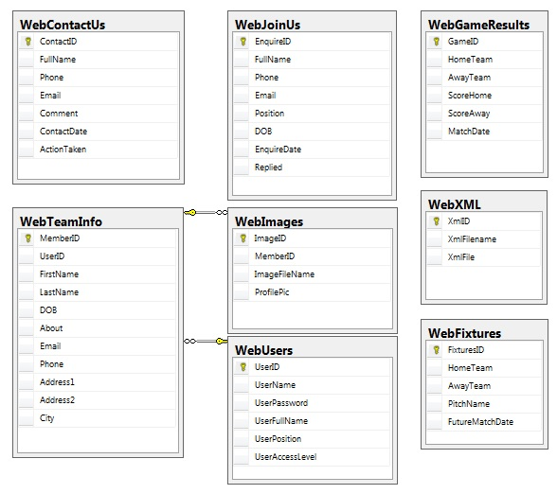

Figure 1 - SQL Server Management Database Diagram

# XML

As mentioned above, content can be stored as XML files. A table of Game results and Team Information are converted to XML with the view of making them easy to transfer across multiple platforms.

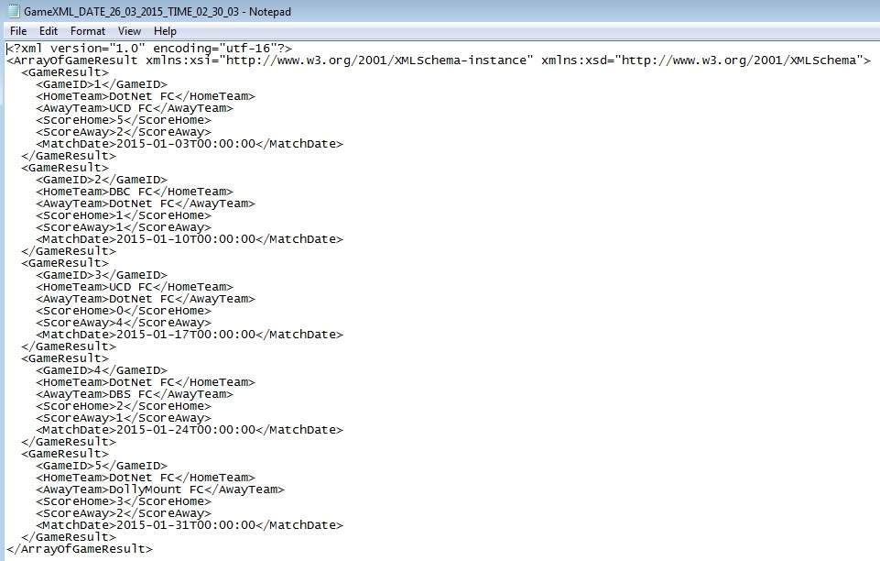

Figure - Sample of XML files generated

# Technologies and Techniques used

I think we should focus on JSON here, as your completed that, can you write about it here?

# Maintenance

Maintenance can be performed on a website either on a regular basis or scheduled when needed. It can be performed with to improve site performance or for security reasons. When websites use the most up to date software, this keeps the website more secure, as well as improving the user experience to the site.

Regular site maintenance should be performed as updating the web page content and keyword information will cause search engines to return to your web site and will aid in search rankings.

# SEO

Several steps were taken to ensure website optimization. Within the siteMaster page, content placeholders were included so each page would specify their own clear and accurate page titles, and another content placeholder was included to give brief description in the meta tag of what that specific page contains.

For optimal SEO we have a clear and legible structure of files, which in turn ensure better URLs. The file names for each web page are relevant to the content being displayed. This way the URLs are easy for users to search and remember.

For our project we only included one site map. Usually two sitemaps would be generated, but as we are not hosting our website, we have not included an XML sitemap, which is used by search engines.

Users like content that is relevant and up to date. By ensuring that our content accurately portrays these criteria, our web site will have more repeat customers. Image optimisation is also very important as people are becoming more attuned to faster web sites. The loading time of each web page should take less than 2 seconds. According to Kissmetrics[1], 47 percent of visitors expect a website to load in less than 2 seconds, and 40 percent of visitors will leave the website if the loading process takes more than 3 seconds.

# Strengths and Weaknesses

## Strenghts

Validation on all text box fields,

## Weaknesess

When creating an XML file, there is no accountability of which coach created the file. Future work would be to amend the WebXML table to account for which user created the file.

XML sitemaps are used to let search engines know about all the pages that exist on a website that are available for crawling, which helps search engines index your content better.

Any user (who is not a guest) who has logged in can upload image. Future work would be to limit the image size that a user can upload for SEO.

Administration personnel currently can only change a team player or coaches “About” section either in the database directly or when site maintenance is being performed. Future work would be to add another option in the Admin page for administration personnel to update the DB directly.

# Individual contribution form – Emma Jane Heneghan

Xxx

# Individual contribution form – Alex Suleac

Xxx

# Appendix A – SQL To Create Tables

## Table 1 WebUsers

CREATE TABLE WebUsers

(

UserID INTEGER IDENTITY (10201, 1) NOT NULL,

UserName NVARCHAR(50) NOT NULL,

UserPassword NVARCHAR(50) NOT NULL,

UserFullName NVARCHAR(100) NOT NULL,

UserPosition NVARCHAR(50) NOT NULL,

UserAccessLevel NVARCHAR(50) NOT NULL,

CONSTRAINT PK_WebUsers PRIMARY KEY(UserID)

)

GO

## Table 2 WebTeamInfo

CREATE TABLE WebTeamInfo

(

MemberID INTEGER IDENTITY (123123, 1) NOT NULL,

UserID INTEGER NOT NULL,

FirstName NVARCHAR(50) NOT NULL,

LastName NVARCHAR(50) NOT NULL,

DOB DATE NOT NULL,

About NVARCHAR(255) NOT NULL,

Email NVARCHAR(100) NOT NULL,

Phone NVARCHAR(10) NOT NULL,

Address1 NVARCHAR(50) NOT NULL,

Address2 NVARCHAR(50) NOT NULL,

City NVARCHAR(50) NOT NULL,

CONSTRAINT PK_WebTeamInfo PRIMARY KEY(MemberID),

CONSTRAINT FK_UserIDFromWebUsers FOREIGN KEY(UserID)

REFERENCES WebUsers(UserID)

)

GO

## Table 3 WebJoinUs

CREATE TABLE WebJoinUs

(

EnquireID INTEGER IDENTITY (1, 1) NOT NULL,

FullName NVARCHAR(100) NOT NULL,

Phone NVARCHAR(10) NOT NULL,

Email NVARCHAR(100) NOT NULL,

Position NVARCHAR(50) NOT NULL,

DOB DATE NOT NULL,

EnquireDate DATETIME NOT NULL,

Replied BIT,

CONSTRAINT PK_WebJoinUs PRIMARY KEY(EnquireID)

)

GO

## Table 4 WebContactUs

CREATE TABLE WebContactUs

(

ContactID INTEGER IDENTITY (1, 1) NOT NULL,

FullName NVARCHAR(100) NOT NULL,

Phone NVARCHAR(10) NOT NULL,

Email NVARCHAR(100) NOT NULL,

Comment NVARCHAR(255) NOT NULL,

ContactDate DATETIME NOT NULL,

ActionTaken BIT,

CONSTRAINT PK_WebContactUs PRIMARY KEY(ContactID)

)

GO

## Table 5 WebGameResults

CREATE TABLE WebGameResults

(

GameID INTEGER IDENTITY (1, 1) NOT NULL,

HomeTeam NVARCHAR(100) NOT NULL,

AwayTeam NVARCHAR(100) NOT NULL,

ScoreHome INTEGER NOT NULL,

ScoreAway INTEGER NOT NULL,

MatchDate DATETIME NOT NULL,

CONSTRAINT PK_WebGameResults PRIMARY KEY(GameID)

)

GO

## Table 6 WebFixtures

CREATE TABLE WebFixtures

(

FixturesID INTEGER IDENTITY (1, 1) NOT NULL,

HomeTeam NVARCHAR(100) NOT NULL,

AwayTeam NVARCHAR(100) NOT NULL,

PitchName NVARCHAR(100) NOT NULL,

FutureMatchDate DATETIME NOT NULL,

CONSTRAINT PK_WebFixtures PRIMARY KEY(FixturesID)

)

GO

## Table 6 WebImages

CREATE TABLE WebImages

(

ImageID INTEGER IDENTITY (10001, 1) NOT NULL,

MemberID INTEGER NOT NULL,

ImageFileName NVARCHAR(50) NOT NULL,

ProfilePic BIT,

CONSTRAINT PK_WebImages PRIMARY KEY(ImageID),

CONSTRAINT FK_UserIDFromWebTeamInfo FOREIGN KEY(MemberID)

REFERENCES WebTeamInfo(MemberID)

)

GO

## Table 7 WebXML

CREATE TABLE WebXML

(

XmlID INTEGER IDENTITY (10001, 1) NOT NULL,

XmlFilename NVARCHAR(50) NOT NULL,

XmlFile NVARCHAR(MAX) NOT NULL,

CONSTRAINT PK_WebXML PRIMARY KEY(XmlID),

)

# Appendix B – SQL To Insert Values into Tables

## Table 1 WebUsers

INSERT INTO WebUsers(UserName, UserPassword, UserFullName, UserPosition, UserAccessLevel)

VALUES

('Alex', 'alex', 'Alex Smith', 'Admin', 'level1'),

('Emma', 'emma', 'Emma Black', 'Admin', 'level1'),

('Sam', 'sam', 'Sam Jones', 'Coach', 'level2'),

('Messi', 'messi', 'Lionel Messi', 'Player', 'level3'),

('Joe', 'joe', 'Joe Bloggs', 'Player', 'Guest'),

('George', 'george', 'George Best', 'Player', 'level3'),

('Cris', 'cris', 'Cristiano Ronaldo', 'Player', 'level3'),

('John', 'john', 'John Rowley', 'DBS Lecturer', 'level1')

## Table 2 WebTeamInfo

INSERT INTO WebTeamInfo(UserID, FirstName, LastName, DOB, About, Email, Phone, Address1, Address2, City)

VALUES

(10201, 'Alex', 'Smith', '1980-01-02', 'Alex is part of the Admin team.', 'alex@dotnet.ie', '0871234567', '12 Dame St', 'Dublin 2', 'Dublin'),

(10202, 'Emma', 'Black', '1987-07-29', 'Emma is part of the Admin team.', 'emma@dotnet.ie', '0871231231', '1 Quays Ave', 'Dublin 1', 'Dublin'),

(10203, 'Sam', 'Jones', '1985-04-01', 'Same has been a coach for the last 20 years.', 'sam@dotnet.ie', '0867897897', 'The Grand Lodge', 'Rathoath', 'Meath'),

(10204, 'Lionel', 'Messi', '1987-06-24', 'Lionel Andrés Messi Cuccittini is an Argentine professional footballer. He is a forward and serves as captain for Argentina.', 'messi@dotnet.ie', '085456456', '123 Barcelona St', 'Dublin 12', 'Dublin'),

(10205, 'George', 'Best', '1987-06-24', ' George Best was a Northern Irish footballer who played as a winger for Manchester United and the Northern Ireland national team.', 'george@dotnet.ie', '085456456', '12 Barna St', 'Dublin 52', 'Dublin'),

(10206, 'Cristiano', 'Ronaldo', '1977-06-21', ' Cristiano Ronaldo dos Santos Aveiro, GOIH, known as Cristiano Ronaldo, is a Portuguese professional footballer.', 'cris@dotnet.ie', '085456456', '75 Okland St', 'Dublin 12', 'Dublin'),

(10207, 'John', 'Rowley', '1992-01-01', ' C# .net Developer, Experienced Web Development Trainer (PHP, SQL, Javascript, .NET (C#), Zend Certified PHP Developer', 'cris@dotnet.ie', '085456456', '75 Okland St', 'Dublin 12', 'Dublin')

## Table 3 WebJoinUs

INSERT INTO WebJoinUs(FullName, Phone, Email, Position, DOB, EnquireDate, Replied)

VALUES

('Joe Bloggs', '0871231237', 'joe@eircom.ie', 'Goalie', '1982-01-09', '2015-02-28', 0),

('Nathan Downey', '0871111231', 'nathan@eircom.ie', 'Forward', '1985-09-29', '2015-02-22', 0)

## Table 4 WebContactUs

INSERT INTO WebContactUs(FullName, Phone, Email, Comment, ContactDate, ActionTaken)

VALUES

('Mark Johnson', '0871234444', 'mar@eircom.ie', 'balh blah comment 1', '2015-02-28', 0),

('Patrick Green', '0871111333', 'patrick@eircom.ie', 'blah blah comment2', '2015-02-22', 0)

## Table 5 WebGameResults

INSERT INTO WebGameResults(HomeTeam, AwayTeam, ScoreHome, ScoreAway, MatchDate)

VALUES

('DotNet FC', 'UCD FC', 5, 2, '2015-01-03'),

('DBC FC', 'DotNet FC', 1, 1, '2015-01-10'),

('UCD FC', 'DotNet FC', 0, 4, '2015-01-17'),

('DotNet FC', 'DBS FC', 2, 1, '2015-01-24'),

('DotNet FC', 'DollyMount FC', 3, 2, '2015-01-31')

## Table 6 WebFixtures

INSERT INTO WebFixtures(HomeTeam, AwayTeam, PitchName, FutureMatchDate)

VALUES

('DotNet FC', 'Trinity FC', 'Alfie Byrne Road', '2015-05-03'),

('DCU FC', 'DotNet FC', 'Herbert Park', '2015-05-10'),

('Trinity FC', 'DotNet FC', 'Kilmore Drive', '2015-05-17'),

('DotNet FC', 'DCU FC', 'Alfie Byrne Road', '2015-05-24'),

('DollyMount FC', 'DotNet FC', 'st Annes Pitch 21', '2015-05-31')

## Table 6 WebImages

INSERT INTO WebImages(MemberID, ImageFileName, ProfilePic)

VALUES

(123126, '6fe30da0-da03-4eb9-ae43-2dc3a85f7ebe-messi.jpg', 1),

(123127, 'dfd01b6c-6dbe-4e66-a7fc-dbdf27683c80-george.jpg', 1),

(123128, '1b169f03-0a4d-4ccc-9e54-6503071c2ee5-cris.jpg', 1)

1. KISSmetrics, *How loading time affects your bottom line*. Available from: <https://blog.kissmetrics.com/loading-time/>. [13 January 2015].